

**Character Profile: ____________**



**PERSONALITY**

**How would you describe your character? Why does he/she behave the way he/she does?**

**PERSONAL INFORMATION**

**Age:**

**Job:**

**Nationality:**

**Where does she/he live?**

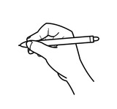

**What do you know about**

**the character? What is her relationship with the other characters?**

**Describe your opinion about him/ her, i.e. (why you like/dislike him/her, why are they in this situation?)**

**DRAW YOUR CHARACTER HERE**