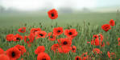
Poppies

1 Three days before Armistice Sunday
and poppies had already been placed
on individual war graves. Before you left,
I pinned one onto your lapel, crimped petals,
5 spasms of paper red, disrupting a blockade
of yellow bias binding around your blazer.
TASK ONE

Read the poem Poppies by Jane Weir and then match each of the images (on page 2) to words or phrases in the poem.
Sellotape bandaged around my hand,
I rounded up as many white cat hairs
as I could, smoothed down your shirt’s
10 upturned collar, steeled the softening
of my face. I wanted to graze my nose
across the tip of your nose, play at
TASK TWO

Choose six of the images and brainstorm all of the associations that come to you from each image: where it can be found, links to particular occasions, who would own the object, what it’s used for, any links to folklore or superstitions, etc.
eg. The blackthorns might make you think of pain, barbed wire, the beauty of nature etc.

being Eskimos like we did when
you were little. I resisted the impulse
15 to run my fingers through the gelled
blackthorns of your hair. All my words
flattened, rolled, turned into felt,

slowly melting. I was brave, as I walked
with you, to the front door, threw
20 it open, the world overflowing
like a treasure chest. A split second
and you were away, intoxicated.
TASK THREE

Write a narrative (story) that includes each of the six objects that you chose.

You can decide what your story is about, but it should feature the objects chosen in a significant way, rather than just mentioning them in passing, eg avoid:

‘I walked to the end of my road and saw a pear tree’

and try something more meaningful like:

‘We used to play under the pear tree and fight for the juiciest fruit. Even now the taste of a ripe pear brings that summer to mind.’

After you’d gone I went into your bedroom,
released a song bird from its cage.
25 Later a single dove flew from the pear tree,
and this is where it has led me,
skirting the church yard walls, my stomach busy
making tucks, darts, pleats, hat-less, without
a winter coat or reinforcements of scarf, gloves.

30 On reaching the top of the hill I traced
the inscriptions on the war memorial,
leaned against it like a wishbone.
The dove pulled freely against the sky,
an ornamental stitch. I listened, hoping to hear
35 your playground voice catching on the wind.

JANE WEIR (b. 1963)

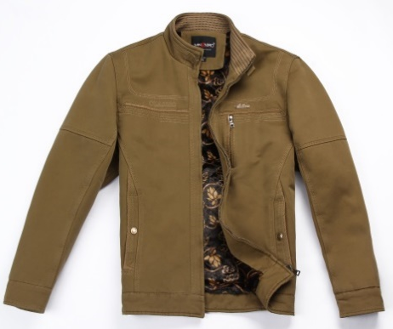 | 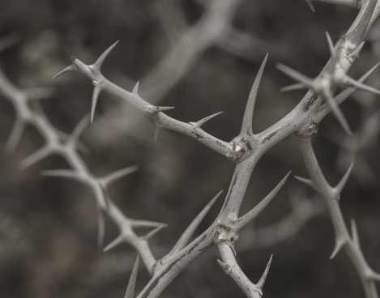 | 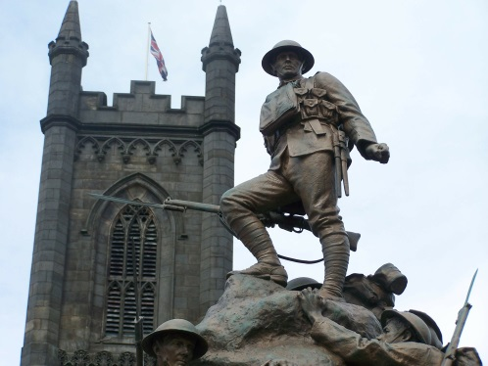
 | 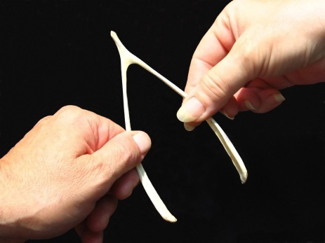
 | 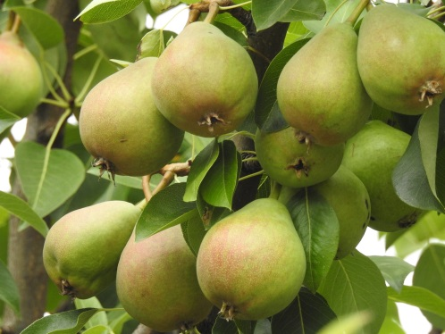 | 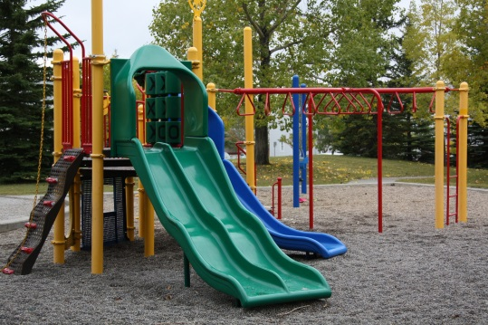
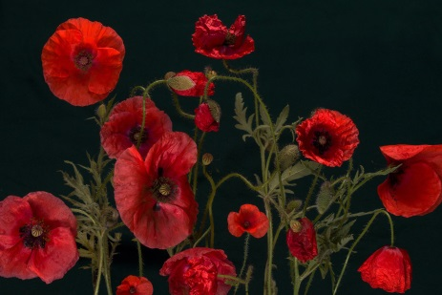 | 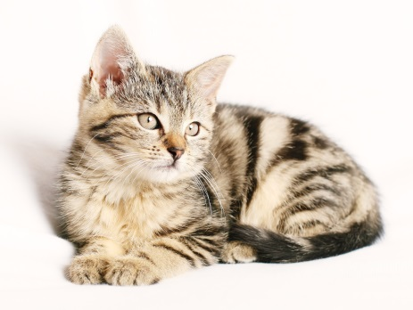 | 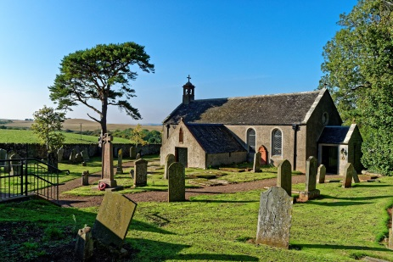
Answer Sheet

