GCSE Sociology Summer Work Pack

Parsons (1961)‘The school class as a social system’
Writing from a functionalist perspective Parsons believed that the school acts as a bridge between the family and society, taking over as the main agency of socialisation and preparing children for adult life. Parsons argued that the schools operate on meritocratic principles: status is achieved on the basis of hard work and effort. In this way the school represents the wider society where, Parsons believed an individual is judged on universalistic standards, which are applied to all members of society. He believed that schools socialise children into the basic values of the wider society, maintaining a value consensus that emphasised achievement and equality of opportunity. Moreover, Parsons believed that schools functioned as an important mechanism for the selection of individuals for their future role in society.
His functionalist perspective has been criticised by those who argue that the values of the education system may simply be those of the ruling elite, or that equality of opportunity is an illusion in an unequal society where wealth and privilege are more important than individual merit.

In your own words, write a summary of the study

What are the key terms used in the study? | What other words are connected to these key terms?
Strengths of the study | Weaknesses of the study

Discuss how far sociologists agree that the education system is meritocratic (12 marks)
The education system IS meritocratic | The education system IS NOT meritocratic

Durkheim (1925) Moral Education
In this classic text, Durkheim considers how education is able to perform the role ofsocialisation: teach children thenorms and valuesof their society.
Durkheim argued that, for society to work, there had to be avalue consensus. People in society had to agree about what was important and how to behave. That way society functions (works) without everything having to be controlled and managed all the time. Education is a crucialagent of socialisation.
Durkheim saw the teaching of History -in particular -as a key part of this socialisation process. He argued that, through learning the history of their country, people learnt to feel part of something bigger than themselves: part of a community. This helps to encourage children to understand that society is important: that they should be interested in other people, not just themselves.
Also, outside the classroom, school encourages children to work together with all sorts of people -not just people they are related to or are particularly close friends with. Again, as with teaching history, this helps children learn to be a part of wider society.
Durkheim was particularly interested in the teaching of morals: right and wrong. This was an important part of teaching values: it is important that there is broad agreement in society about what is right and what is wrong. Also, in school, behaviour can be strictly controlled. Durkheim thought it was important to have strict discipline in school. That way, children would learn what was acceptable or not. Through this, by the time children leave school, most will have learnt self-discipline and not need to be controlled. They should also have learned that misbehaviour has negative consequences, both for themselves and for society.
Critics of Durkheim would suggest that these lessons do not benefit the whole of society but only powerful groups. Marxists would suggest it is the ruling class who benefits, and feminists would suggest it is men who benefit.

List the main functions of education according to Durkheim. Add an image to assist with recall.

Challenge: Identify another criticism of this study, different to those mentioned above.

True or False? Highlight the correct statements.
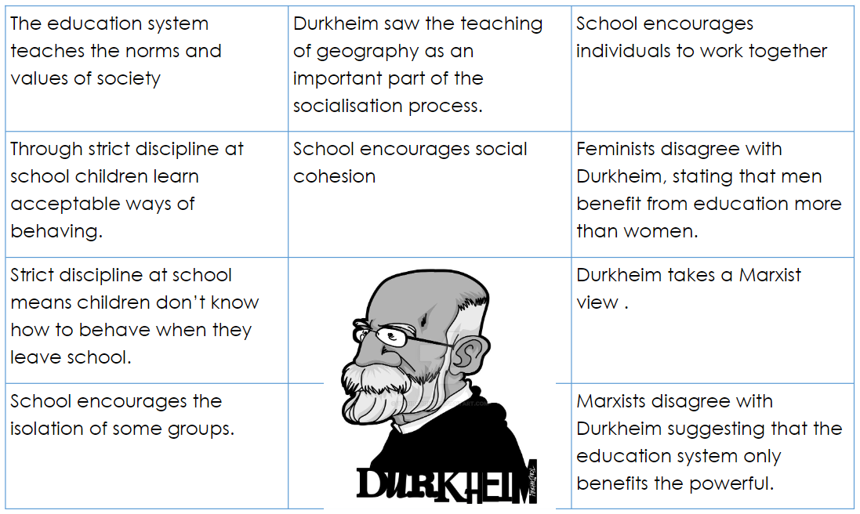
Identify and explain one function of the education system according to Durkheim, including what you know of his perspective. (4 marks)

Paul Willis (1977) Learning to Labour
Paul Willis used a wide range of research methods -including observations and interviews -to really try and see education from the children's point of view. As a Marxist, he was interested in conflict in education and why working-class children went on to do working-class jobs. But he reached quite different conclusions from Bowles & Gintis.
Willis' study of working-class boys in a Midlands school has become a classic. His study focused on "the lads" -a group of working-class boys who were disruptive, misbehaved and had a very negative attitude to education. They had formed what Willis called ananti-school subculture. Within this subculture it was "cool" to "mess about" and to fail. It really turned the values of the school on their head. From the perspective of this subculture, children who the school viewed positively were the "ear'oles" ("swots"). The last thing you wanted was praise from a teacher. Instead, children could get praise within the group for truancy, bad behaviour and discriminatory attitudes (there was a lot of racism, sexism and homophobia within the group).
With these findings, Willis does not only undermine the arguments of Parsons or Durkheim, but also of his fellow Marxists, Bowles & Gintis. First, he concluded that school was not working very well as an agent of socialisation: there was no value consensus here: pupils were actively rejecting the norms and values of society. As such, they were a long way from the hard-working, docile, obedience workers suggested by Bowles & Gintis! And yet the outcome was much the same: the children of working-class parents going on to do working-class jobs. In this study they played an active role in this: they thought school was boring and pointless and was something they had to endure until they could go to work. They had a similar attitude to work, and got through it using similar techniques: "messing about" and "having a laff".
Willis used a wide range of research methods (known as methodological pluralism) to try and get as true a picture as possible. However, it has been suggested that the boys may have acted up more to "show off" to Willis. This might have occurred when they were being observed (the Hawthorne Effect-people behave differently when they know they're being watched) and when they were interviewed (an interviewer effect).
While Willis was coming from a Marxist perspective, his study does suggest that working-class boys actively chose to fail, rather than the system being designed by the capitalist class to have this outcome. He did suggest that this ultimately benefited capitalism, because there wasn't a meritocracy and instead class inequality was reproduced, and there would not be a revolution because workers had learnt a coping strategy for doing boring, unfulfilling work ("having a laff"). However, it did not produce the productive, docile workers capitalists might ideally like to have working for them!

Find out and Think
After reading the information, complete the ‘find out’ questions. Then, apply your knowledge and attempt the ‘think’ questions.
Find out: What research methods were used by Willis in his study ‘Learning to Labour’?

Think: What are the strengths and weaknesses of these research methods?

Find out: Describe the sample in his study

Think: Is it possible to generalise the findings from this study? Explain why/why not.

Find out: What examples of behaviour were praised within the anti-school subculture?

Think: What factors, other than social class, might cause a student to join an anti-school subculture?

Find out: What is the phrase used to describe using a range of research methods?

Think: What are the benefits of using more than one research method?

Find out: Describe the Hawthorne effect and interviewer effect.

Think: How could a researcher avoid the Hawthorne effect and interviewer effect?

Find out: How do Willis’ findings differ to other Marxist views of education?

Think: How can this study be evaluated?

